
INFORMATION SECURITY ASSIGNMENT
Part-01

August 27, 2025

Name: Muhammad Faizan Yousaf, Muhammad Haris
Section: BCS 7-F
Roll number: 22F-3875,22F-8789

Submitted to: Sir Umar Aftab

Wi-Fi Hacking Assignment Report

Ethical Testing of a Personal Mobile Hotspot

Introduction
This report details an educational exercise on Wi-Fi hacking, conducted ethically on my personal mobile hotspot for an Information Security course. The goal was to learn about Wi-Fi vulnerabilities, such as weak passwords, by simulating a WPA2 handshake capture and password cracking. This was done legally, targeting only my own network, to understand how attackers exploit weaknesses and how to secure networks better. The experiment used Kali Linux and tools like Aircrack-ng, following ethical hacking principles.

Objectives

Here are some of the Objectives listed below:
- Understand Wi-Fi vulnerabilities, especially weak passwords.
- Learn to use ethical hacking tools like Aircrack-ng.
- Capture a WPA2 handshake from my mobile hotspot.
- Attempt to crack the password using a dictionary attack.
- Identify ways to improve Wi-Fi security.

Setup
To perform this experiment safely, I used the following:
- Tool: Kali Linux, a free operating system for security testing, installed on a virtual machine using VirtualBox.
- Hardware: A Wi-Fi adapter (Realtek RTL8188EU Wireless LAN 802.11n USB 2.0) that supports monitor mode, necessary for capturing Wi-Fi signals.
- Target: My personal mobile hotspot, set up on my phone with a simple WPA2 password 12345678 for testing.
This ensured no unauthorized networks were targeted, keeping the experiment legal and ethical.

4. Step-by-Step Process
The experiment simulated a common attack where an attacker captures a Wi-Fi handshake and tries to guess the password. Below are the steps I followed:

Step 1: Setting Up Kali Linux
    - Downloaded Kali Linux from kali.org and installed it in VirtualBox.
    - Updated the system by running sudo apt update && sudo apt upgrade.
    - Installed Aircrack-ng, a tool for WiFi analysis, using sudo apt install aircrack-ng.

Step 2: Enabling Monitor Mode
    - Checked my Wi-Fi adapter’s name using iwconfig (it was wlan0).
    - Turned on monitor mode with sudo airmon-ng start wlan0, creating a new interface called wlan0mon.

Step 3: Scanning for Networks
    - Ran sudo airodump-ng wlan0 to see nearby Wi-Fi networks.
    - Found my hotspot’s BSSID (a unique address like 00:11:22:33:44:55) and channel (e.g., 6).

Step 4: Capturing the Handshake
    - Focused on my hotspot with sudo airodump-ng -c 6 –bssid 00:11:22:33:44:55
-w capture wlan0.
    - In another terminal, forced a device to reconnect by sending a de-authentication packet:
sudo aireplay-ng -0 1 -a 00:11:22:33:44:55 -c [client MAC] wlan0.
    - Waited until airodump-ng showed “WPA handshake” in the top-right corner, confirming capture.
    - This screenshot shows the successful capture of a WPAhandshake using airodump-ng, a critical step in simulating a Wi-Fi password attack.
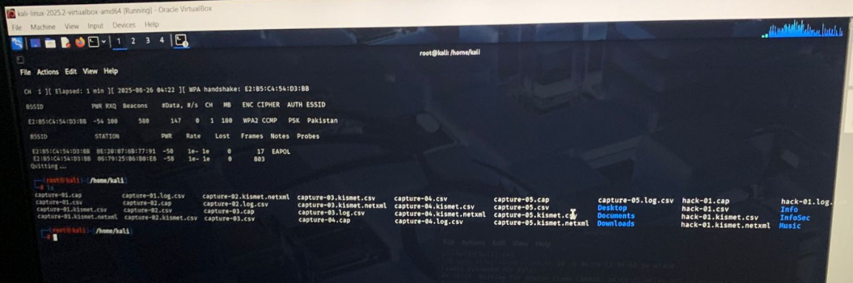

Step 5: Cracking the Password
    - Used a wordlist (rockyou.txt, a common list of passwords) for a dictionary attack.
    - Ran sudo aircrack-ng -w rockyou.txt capture-01.cap.
    - The tool cracked the password 12345678 quickly because it was simple, showing why weak passwords are risky.
    - This screenshot displays the password cracking process using aircrack-ng with a wordlist, demonstrating how a weak password 12345678 was quickly cracked

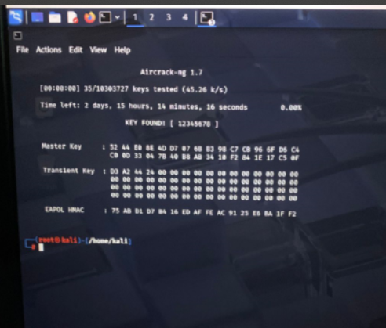

Step 6: Cleaning Up
    - Stopped monitor mode with sudo airmon-ng stop wlan0mon.
    - Restarted the network manager to restore normal WiFi: sudo systemctl start NetworkManager.

Findings
The experiment showed how easy it is to crack a weak Wi-Fi password using tools like Aircrack-ng. The simple password 12345678 was guessed quickly because it was in the rockyou.txt wordlist. This highlights the danger of weak passwords. The handshake capture was successful because I could force a device to reconnect, a common attacker trick.

Recommendations
To secure WiFi networks, I suggest:
- Use strong passwords (12+ characters, with letters, numbers, and symbols).
- Enable WPA3 if your devices support it; otherwise, use WPA2.
- Disable WPS to prevent bypass attacks.
- Regularly update router firmware to fix vulnerabilities.
- Monitor connected devices to spot intruders.

Conclusion
This exercise taught me how attackers can exploit Wi-Fi networks and why strong security practices are critical. By cracking my own hotspot’s password, I saw firsthand the importance of complex passwords and modern encryption like WPA3.

References
- Kali Linux Official Website: https://kali.org
- Aircrack-ng Documentation: https://www.aircrack-ng.org

-----------------------------------------------------END-----------------------------------------------------------

